Final Report on Bloom Filter

Based on the result I received from the test case, it is clear that this version of bloom filter is working.

In addition, based on the results in 4.2 extended practices, I found that there appeared to be a negative correlation between false positive rate and the size of bitmap array used in bloom filter. At first, the fp rate was close to 0.7. However, as the size of bitmap increases, the fp rate quickly fell below 0.005 – sometime even close to 0.001. In conclusion, there is a tradeoff between lower positive rate and lower memory usage.

In addition, when comparing the estimated size of bloom filters with the actual size returned by the code, it appears that the actual size is much lower than the calculated theoretical size (see calculation below). 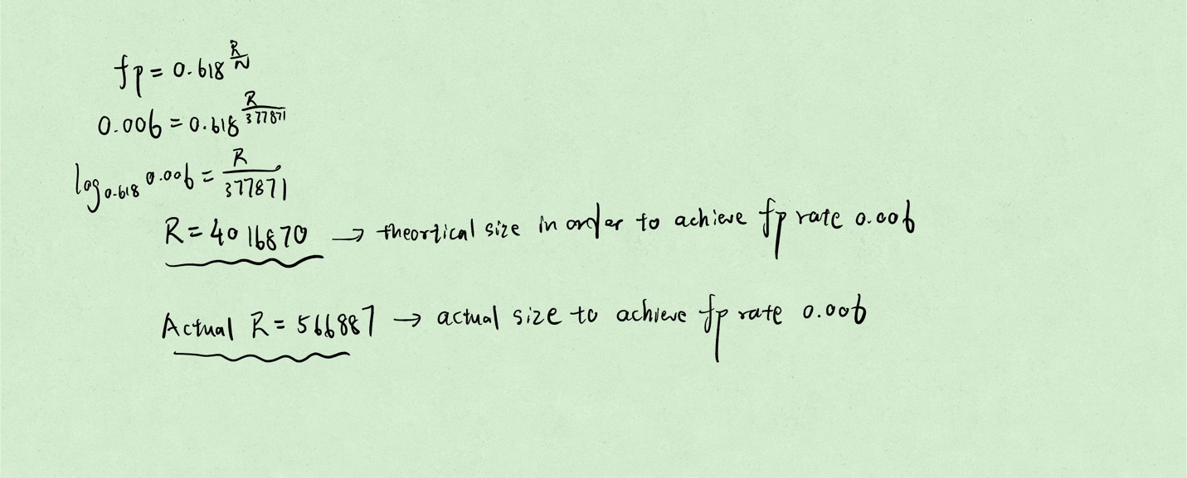

Finally, in terms of the comparison between hash table and bitmap array, the size of hash table is roughly 4 times larger than the size of bitmap array.